# Monster Extermination

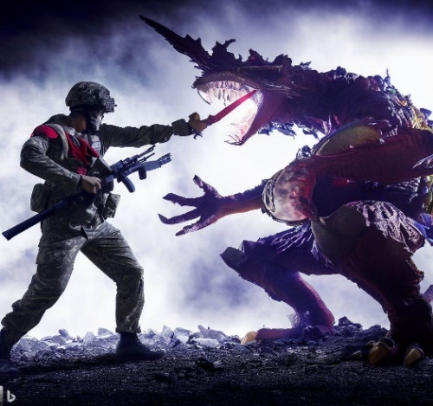

*You are tasked with simulating a battle between a brave soldier and a group of terrifying monsters. The soldier has a striking impact, and the monsters have different levels of armor. Your task is to write a program that takes two sequences of integers as input from the console and performs the battle simulation.*

There will be given **two sequences of integers**.

The **first sequence** represents the **armor of the monsters**. **Each integer value** represents the **armor of a different monster**.

The **second sequence** represents the **soldier's striking impact**. **Each integer value** represents the **strength of a strike** performed by the soldier.

**Battle Rules:**

* The monster at the front will be the first to face the soldier. Take the **first armor value** and the **last strike strength value** and compare the values.
* If the **soldier's striking impact** **is greater than or equal to the monster's armor**, the monster is killed, and its **armor is removed from the sequence**. The soldier's strike **impact is then decreased by the value of the monster's armor**. The **remaining striking impact value** is **added to the next strike element** in the sequence (if any) or is considered to be the **last** and **only element**. **Zero values** should **not be pushed back** to the **sequence**.
* If the **soldier's striking impact is less than the monster's armor**, the strike is performed, but the monster survives with **reduced armor**. The **soldier's striking impact value is removed from the sequence**, and the **monster's armor value is decreased by the original strike value**. The **monster is then moved to the back of the sequence**.
* The battle goes on **until one of the sequences becomes empty**.

Write a **console application** to simulate the battle as described above. **Implement the battle logic using appropriate data structures** to manage the soldier's striking impact and the monsters' armor values. The program should then **display the appropriate outcome of the battle** based on the rules.

## Input

* The first line will represent the **armor values - integers**, **comma-separated** values**.**
* The second line will represent the **soldier's striking impact values** - **integers**, **comma-separated** values.

## Output

* If **all the monsters are killed**, the program should print on the Console a success message:
  + **"All monsters have been killed!"**
* If **the soldier's striking impact stack becomes empty**, the program should print on the Console a message indicating that the soldier has been defeated:
  + **"The soldier has been defeated."**
* The program should **print on the Console the total number of monsters killed** by the soldier, **on a new line**:
  + **"Total monsters killed: {killedMonsters}"**

|  |  |
| --- | --- |
| **Input** | **Output** |
| 20,15,10  5,15,10,25 | All monsters have been killed!  Total monsters killed: 3 |
| **Comment** | |
| 1. The soldier’s first strike (last in the sequence) (25) is greater than the first monster's armor (20). **Monster 1 is killed**. Its **armor value is removed** from the sequence. The soldiers’ striking impact value is decreased by the monster’s armor value and it remains (5). It is **added to the next element** in the sequence (10) 2. The soldier’s second strike (15 {10 + 5}) is equal to the second monster's armor (15). **Monster 2 is killed**. Its **armor value is removed** from the sequence. The soldiers’ striking impact value is decreased by the monster’s armor value and it remains (0). It is not necessary to be added to the next element. It just can be **removed from the sequence**. 3. The soldier’s third strike (15) is greater than the third monster's armor (10). Monster 3 is killed. Its **armor value is removed** from the sequence. The monster’s armor sequence is empty, so the program ends, and the **output is printed on the Console.** All monsters have been killed. The soldier wins the battle, having killed 3 monsters. | |
| **Input** | **Output** |
| 30,25,40,35  15,20,10,30 | The soldier has been defeated.  Total monsters killed: 1 |
| **Comment** | |
| 1. The soldier’s first strike (30) is equal to the first monster's armor (30). **Monster 1 is killed**. Its **armor value is removed** from the sequence. The soldiers’ striking impact value is decreased by the monster’s armor value and it remains (0). It is not necessary to be added to the next element. It just can be **removed from the sequence**. 2. The soldier’s second strike (10) is less than the second monster's armor (25). Monster 2 survives with 15 armor remaining. **Monster 2 moves to the back of the sequence**. 3. The soldier’s third strike (20) is less than the third monster's armor (40). Monster 3 survives with 20 armor remaining. 4. The soldier’s fourth strike (15) is less than the fourth monster's armor (35). Monster 4 survives with 20 armor remaining. 5. The soldier has no more strikes left, but there are still three monsters remaining. The soldier is defeated, having killed 1 monster. | |